1.INTRODUCTION

* 1. Overview

I Design a Invitation using in this canva.

That was very easy to use.Anyone to use this canva easier.

* 1. Purpose

My project is creating an invitation.

I create a invitation using this canva.

2.Empathy Map

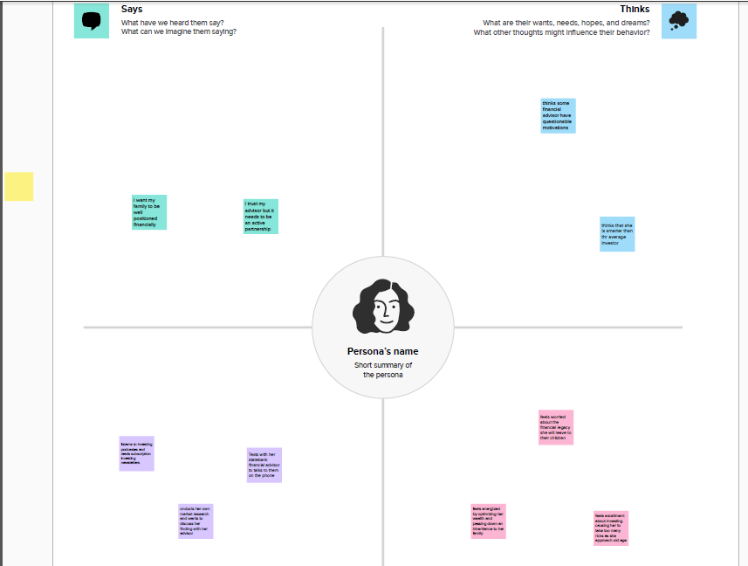

3. Brainstorming Map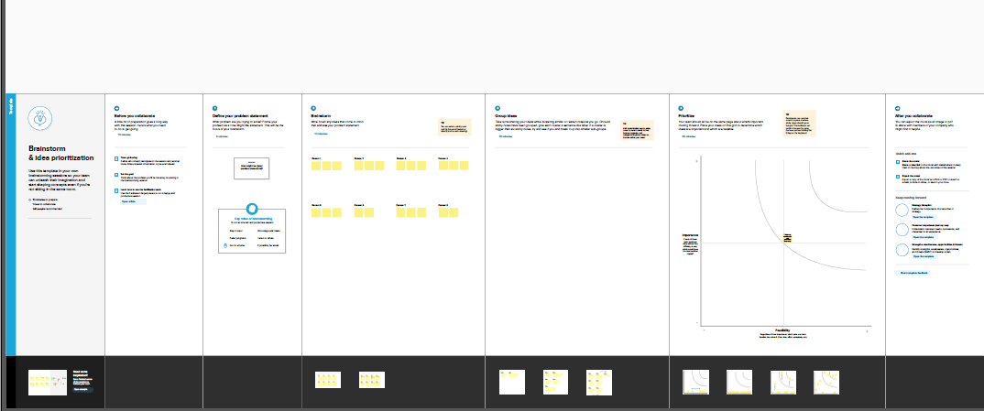

4.RESULT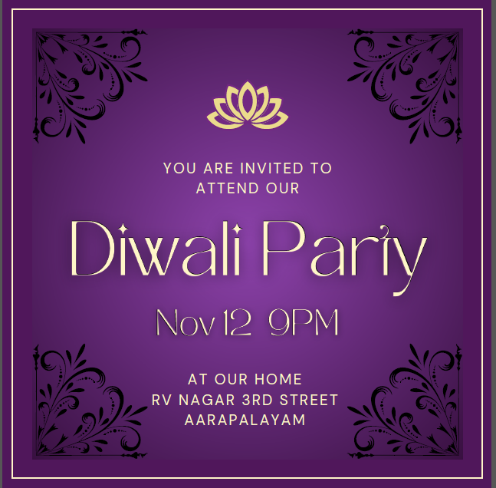

5.Advantage And Disadvantage

Easy to use this canva

Canva was very useful to everyone

Data issues while using canva

6.Conclusion

I easily finish my project using canva. In this canva we have lots and lots templetes for the project use. Its very helpful for the users.